**AIM:** Write a program to implement depth limited search Algorithm in Python Programming Language.

**CODE:**

ADJ = {}

"""""

SRRXG

RXRXR

RRRXR

XRXRR

RRRRX

"""""

ADJ['S'] = ['2', '6']

ADJ['2'] = ['S', '3']

ADJ['3'] = ['2','8']

ADJ['G'] = ['10']

ADJ['6'] = ['S', '11']

ADJ['8'] = ['3', '13']

ADJ['10'] = ['G', '15']

ADJ['11'] = ['6', '12']

ADJ['12'] = ['11', '13', '17']

ADJ['13'] = ['8', '12']

ADJ['15'] = ['10', '20']

ADJ['17'] = ['12','22']

ADJ['19'] = ['20', '24']

ADJ['20'] = ['15','19']

ADJ['21'] = ['22']

ADJ['22'] = ['17','21','23']

ADJ['23'] = ['22', '24']

ADJ['24'] = ['19','23']

print ("adj",ADJ)

# keep track of visited nodes

visited = {str(i) : False for i in range(1,26)}

visited['S'] = False

visited['G'] = False

def dls(start, goal,limit):

  depth = 0

  OPEN=[]

  CLOSED=[]

  OPEN.append(start)

  visited["S"] = True

  while OPEN != []: # Step 2

   if depth<=limit:

       current = OPEN.pop()

       if current == goal:

         print("Goal Node Found")

         return True

       else:

         lst = successors(current)

         for i in lst:

    # try to visit a node in future, if not already been to it

            if (not(visited[i])):

               OPEN.append(i)

               visited[i] = True

         depth +=1

   else:

     print("Not found within depth limit")

     return False

   print(OPEN)

      #print(\"node visited\",i,sep='>',end='\\n')

  return False

def successors(city):

   return ADJ[city]

def test():

   start = 'S'

   goal = 'G'

   limit=int(input("ENTER THE DEPTH LIMIT"))

   print("Starting a dls from [ " + start+" ]")

   print(dls(start, goal,limit))

if __name__ == "__main__":

  test()

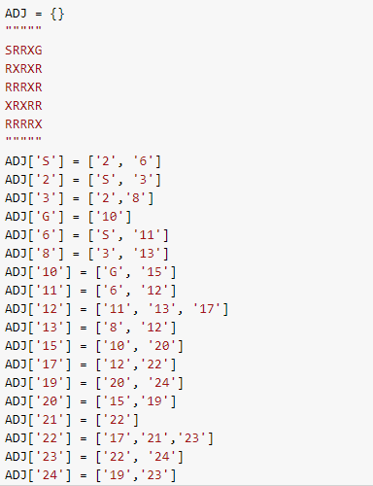

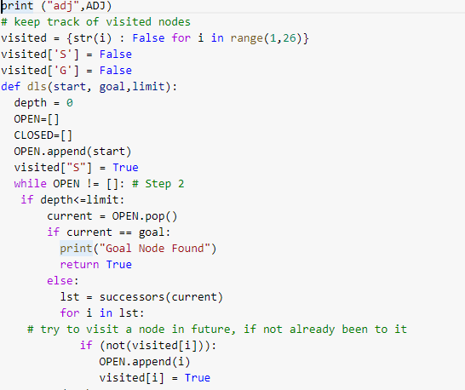

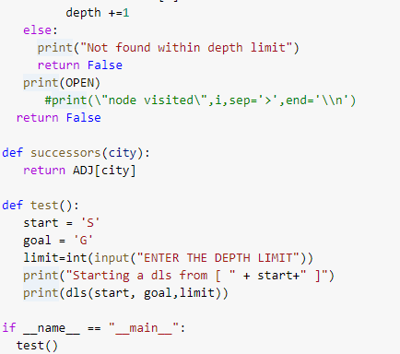

**OUTPUT:**

